**PROJECT**

**Full Microsoft 365 + Intune Environment for a New Company**

This project started as a simple challenge: to build a complete, enterprise‑grade Microsoft 365 environment from scratch. What began as a small experiment quickly evolved into a fully functioning modern workplace ecosystem that mirrors how real organisations manage identity, devices, security, and collaboration.

I designed the core foundation in Entra ID, created users and departments, and built Teams, SharePoint, and Microsoft 365 Groups using scalable, best‑practice structures. From there, I moved into device management—enrolling Windows devices into Intune, applying compliance and configuration policies, deploying apps, and transforming fresh machines into secure, fully managed workstations.

The project came to life through real IT workflows. I built an end‑to‑end onboarding process that provisions accounts, licenses, Teams access, apps, and devices, as well as an offboarding workflow that locks accounts, preserves data, wipes devices, and transitions resources safely. Along the way, I solved real‑world issues like enrollment failures, licensing conflicts, and sync errors, documenting each fix as part of the learning process.

By the end, I had created more than a lab—I built a secure, organised, automated digital workplace. This project reflects my ability to think like an IT administrator and deliver systems that are reliable, scalable, and user‑friendly. It’s a hands‑on journey of learning, problem‑solving, and building something meaningful from the ground up.

**Scenario**

You’ve been hired as the IT Support Technician for a fictional company called:

**Suraj365lab Solutions**

Your job is to design and implement:

* Microsoft 365 identity
* Security groups
* Email system
* Teams’ collaboration
* SharePoint sites
* Intune device management
* Security policies
* Onboarding & offboarding workflows

**Project Objectives**

* Build a complete Microsoft 365 tenant
* Create users, groups, and roles
* Configure MFA & Conditional Access
* Deploy Intune and enroll devices
* Create compliance & configuration policies
* Deploy apps to devices
* Build SharePoint sites
* Configure Teams
* Simulate onboarding & offboarding
* Document everything like a real IT technician

**PHASE 1 — Identity & Access (Entra ID)**

**Task 1: Create Users**

Create these users:

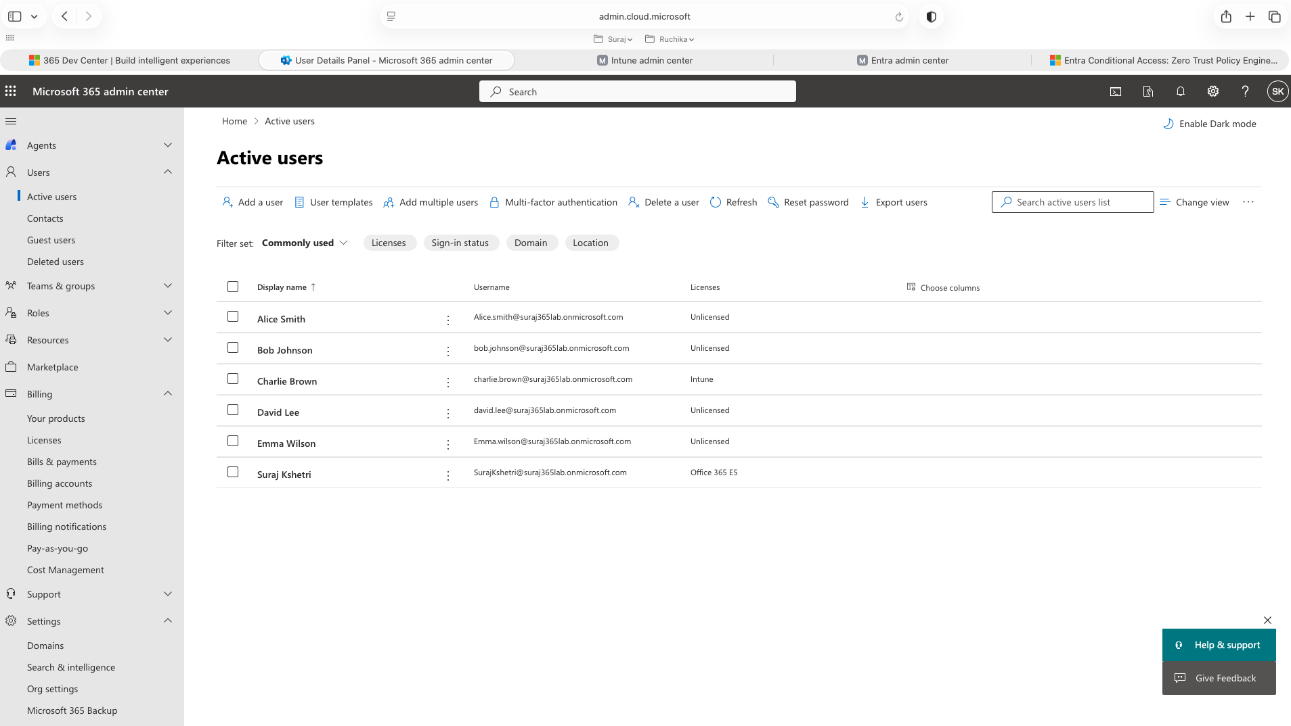

**Task 2: Create Security Groups**

Create:

* All‑Users
* HR‑Team
* Sales‑Team
* IT‑Support
* Intune‑Windows‑Devices
* Intune‑macOS‑Devices

**Task 3: Assign Roles**

* Make **Charlie Brown** → Helpdesk Admin
* Make **your admin account** → Global Admin + Intune Admin

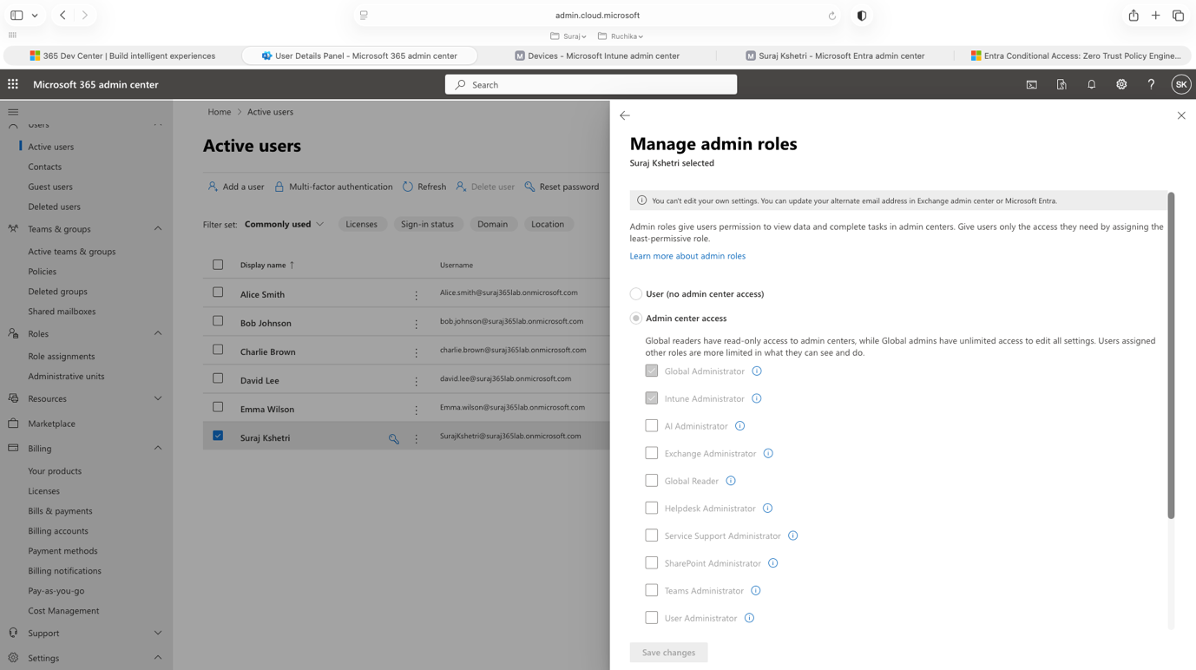

**Task 4: Enable MFA**

Enable MFA for all users.

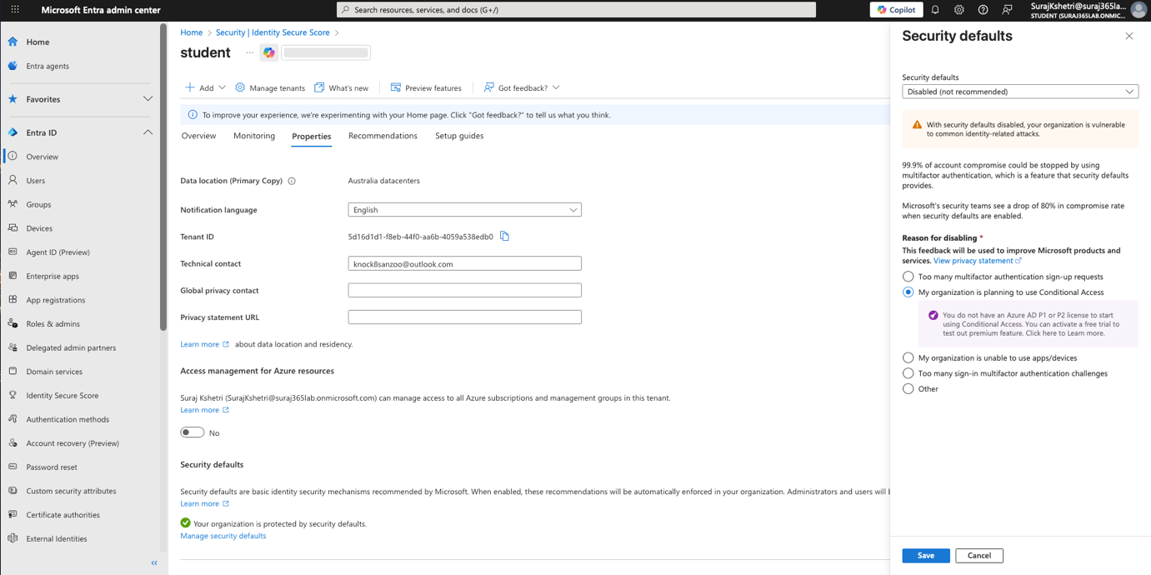

**Task 5: Create Conditional Access Policies**

* Require MFA for all users

* Block legacy authentication
* Require compliant device for Exchange Online

**PHASE 2 — Intune Device Management**

**Task 6: Configure MDM Enrolment**

* Enable MDM auto‑enrolment
* Set MDM scope → All users

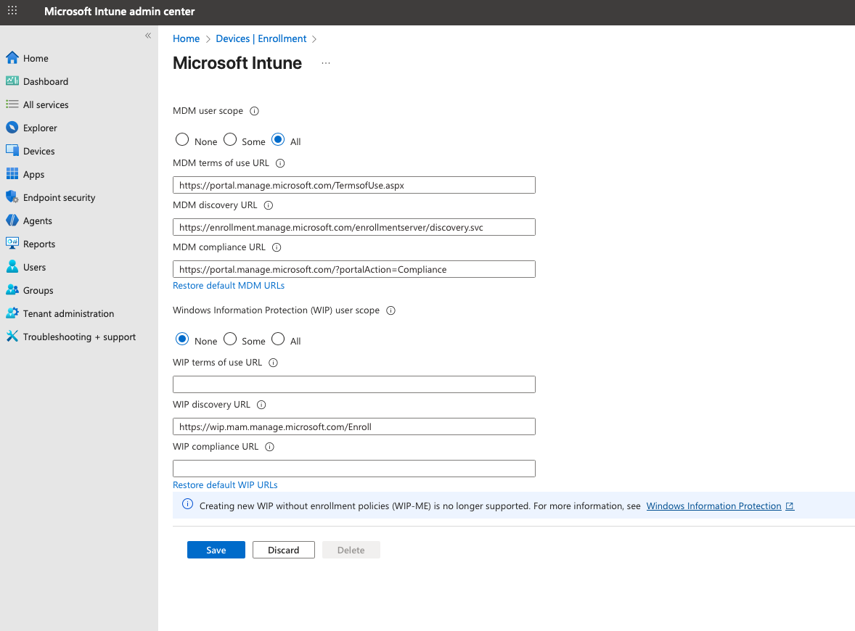

**Task 7: Enroll Devices**

* One Windows11 VM

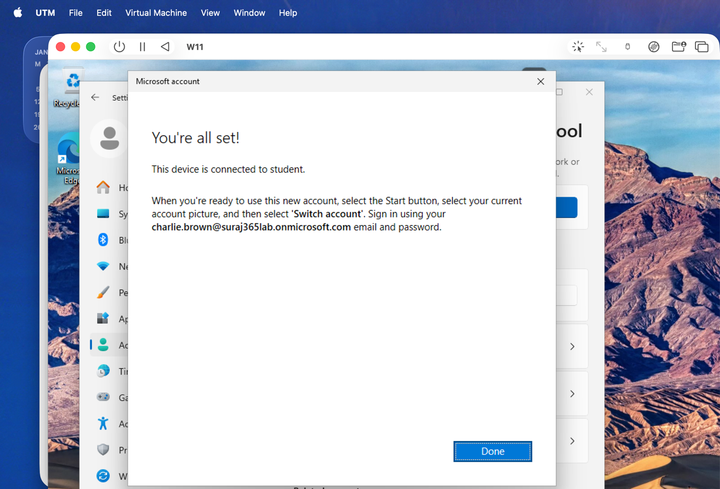

**Task 8: Create Compliance Policies**

Windows compliance policy:

* Require BitLocker
* Require password
* Require firewall
* Require secure boot

Assign to: **Intune‑Windows‑Devices**

**Task 9: Create Configuration Profiles**

* Disable USB storage
* Set lock screen timeout
* Configure password rules
* Enable BitLocker

**Task 10: Deploy Apps**

* Microsoft Edge
* Office 365

**PHASE 3 — Exchange Online (Email System)**

**Task 11: Create Shared Mailboxes**

* [support@suraj365lab.onmicrosoft.com](mailto:support@skytech.onmicrosoft.com)

* [hr@suraj365lab.onmicrosoft.com](mailto:hr@skytech.onmicrosoft.com)

Assign permissions:

* IT Support → Support mailbox
* HR Team → HR mailbox

**Task 12: Create Distribution Lists**

* All Staff
* Sales Team
* HR Team

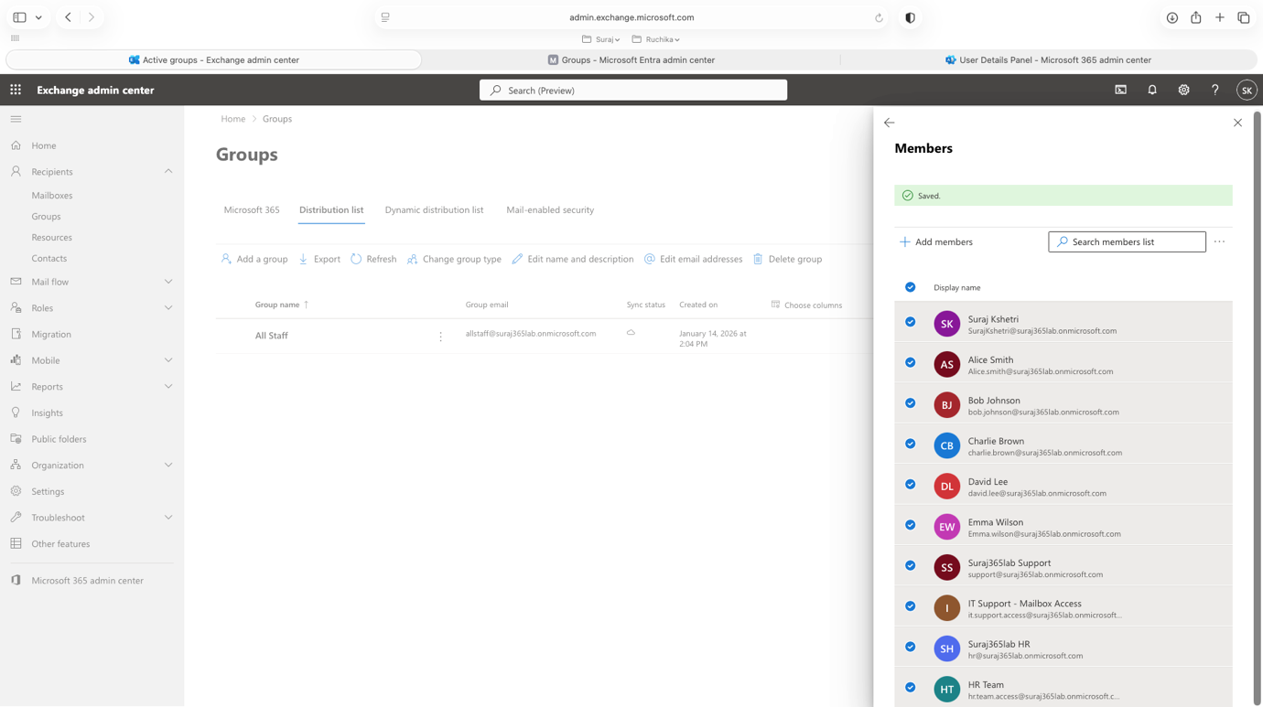

**PHASE 4 — SharePoint & OneDrive**

**Task 13: Create SharePoint Sites**

* HR Site

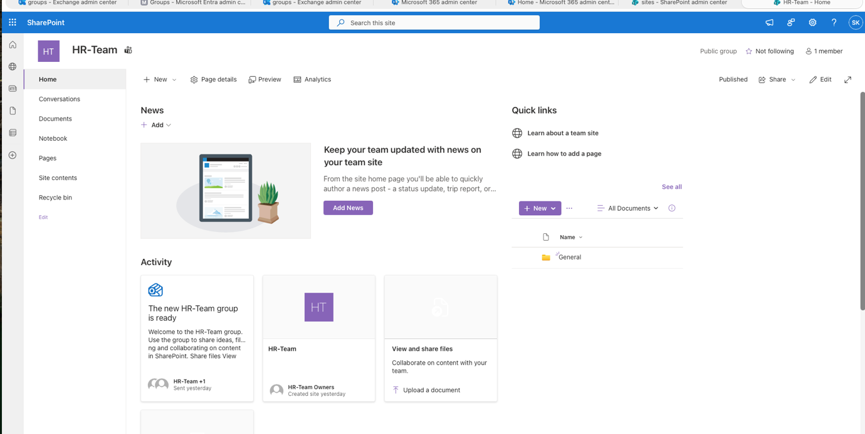

* Sales Site

* IT Support Site

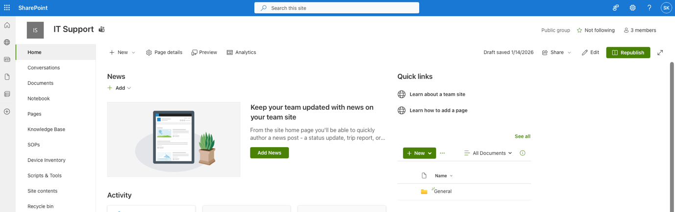

Configure:

* Permissions

* Document libraries

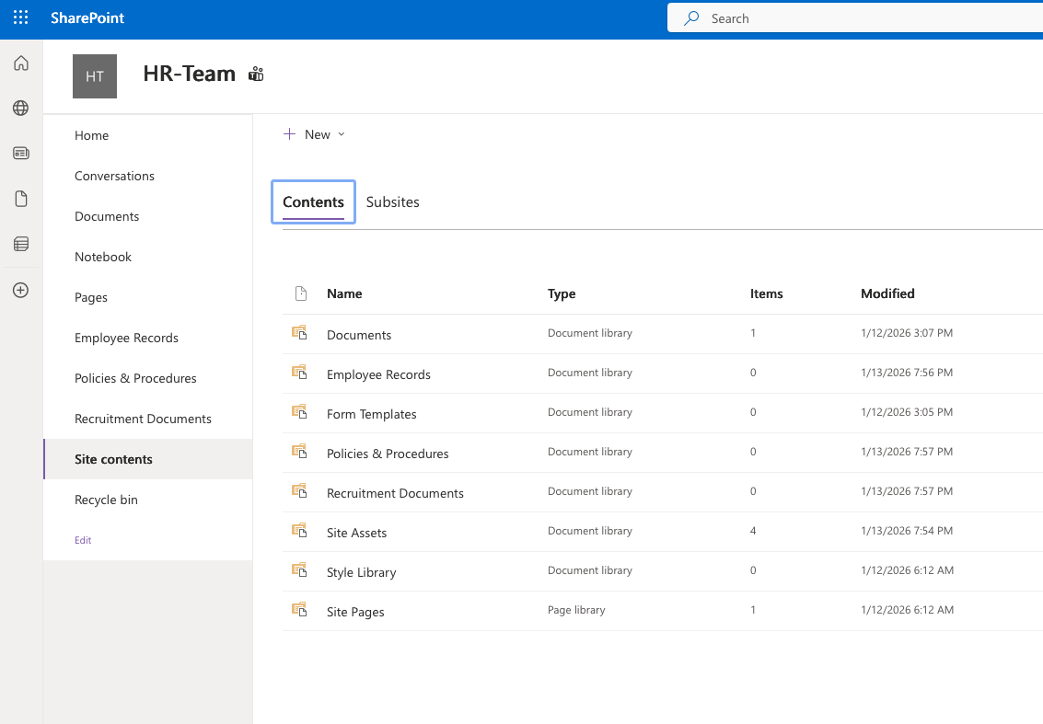

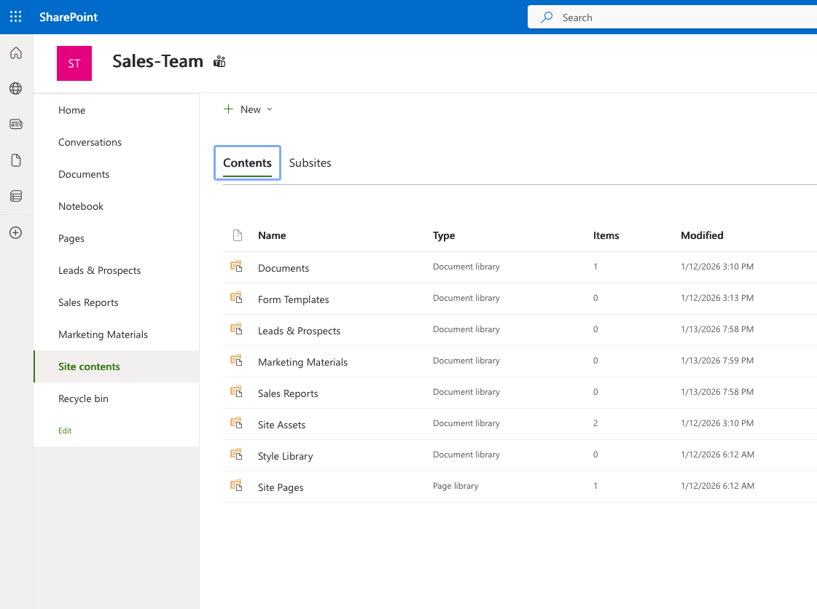

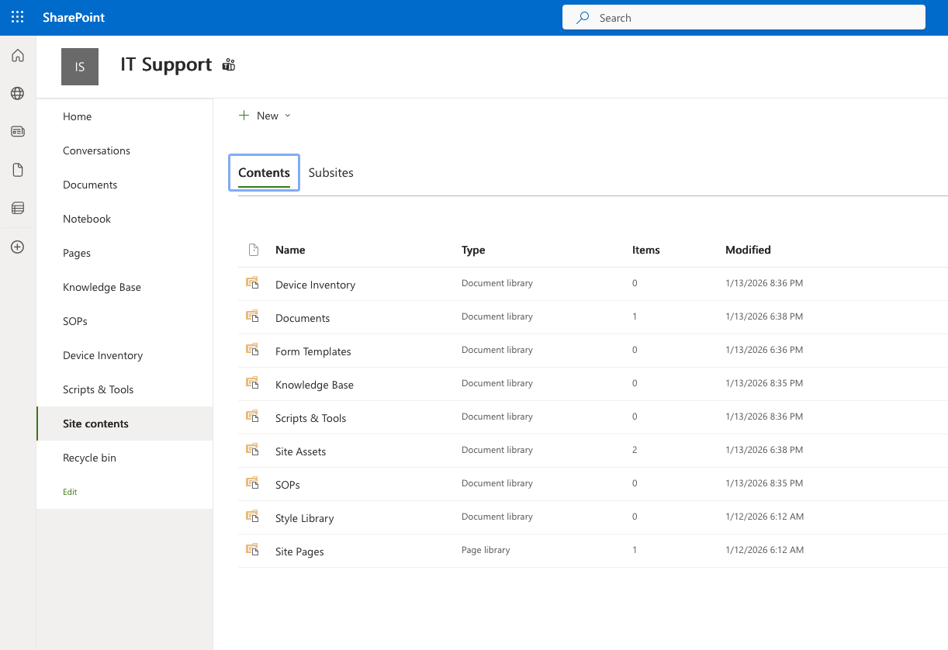

* Sharing settings

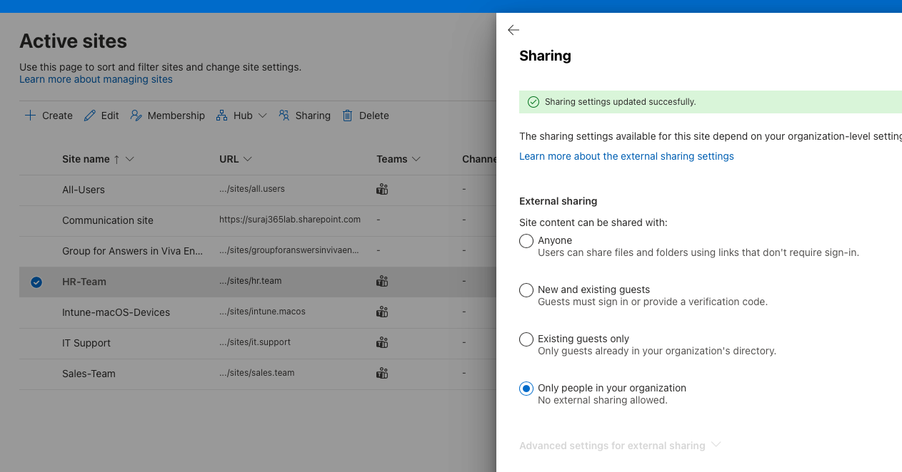

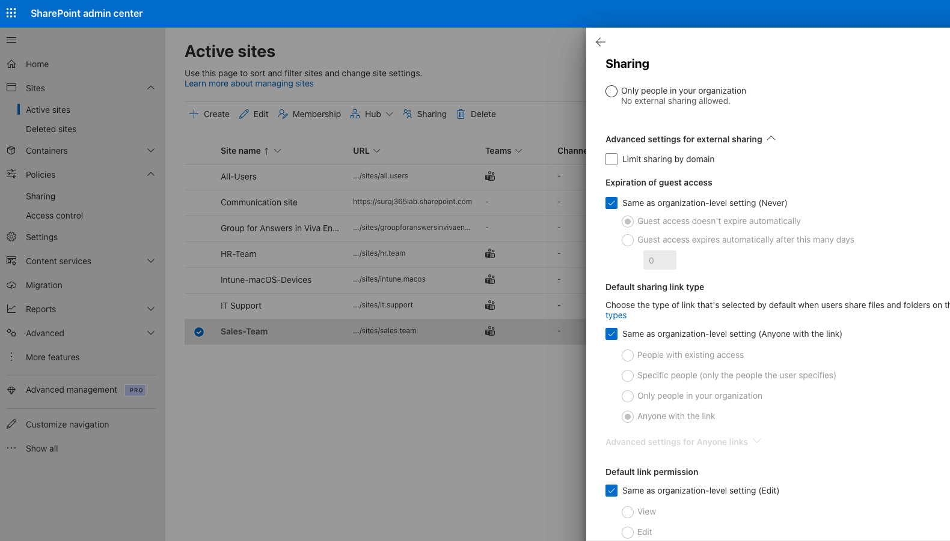

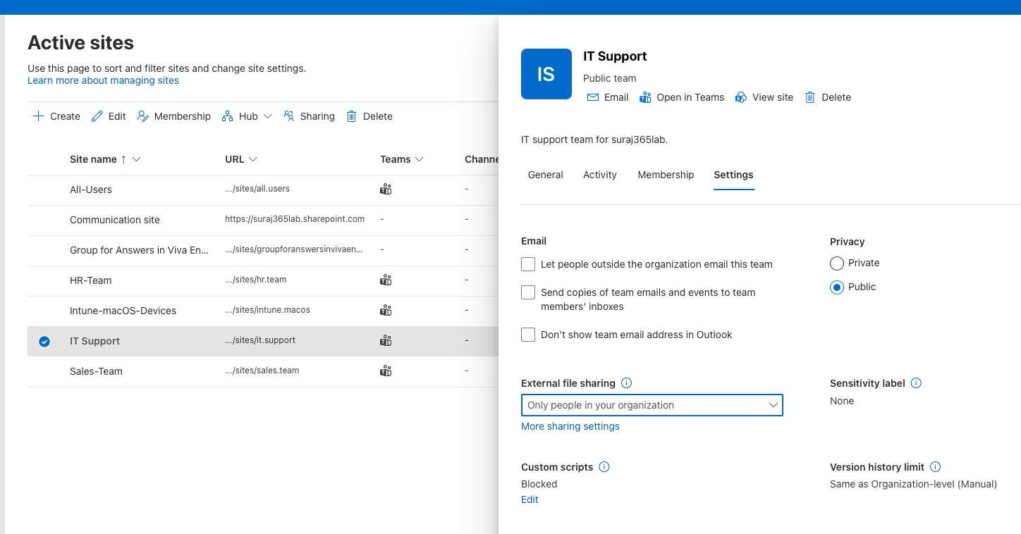

**PHASE 5 — Teams Collaboration**

**Task 14: Create Teams**

* HR Team
* Sales Team
* IT Support Team

Add:

* Channels
* Members
* Owners

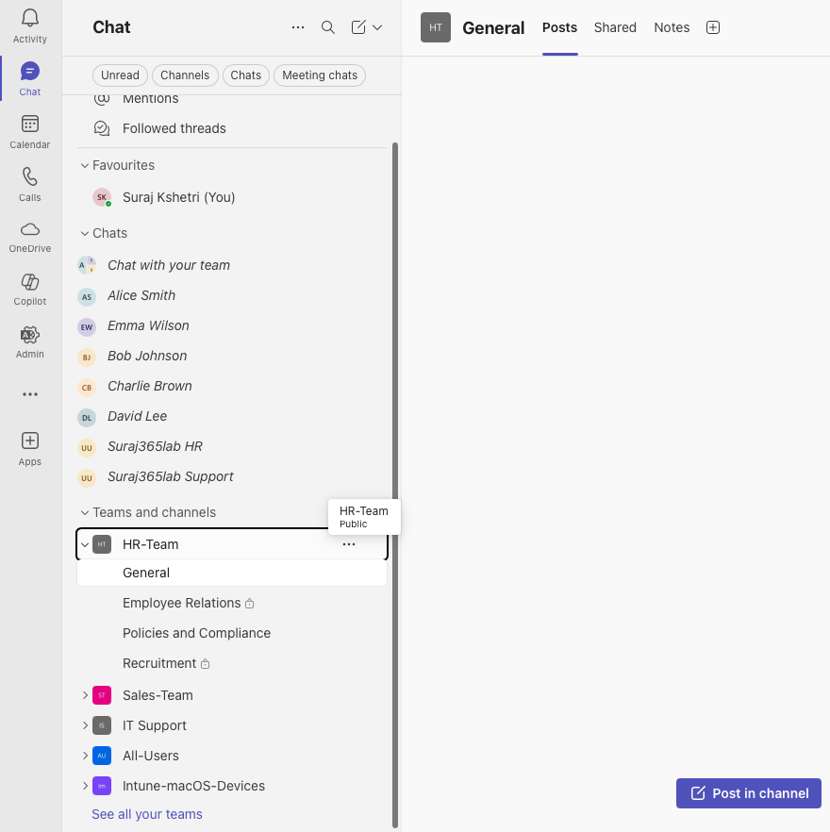

**PHASE 6 — Security & Compliance**

**Task 15: Create Sensitivity Labels**

* Public
* Internal
* Confidential

Apply to:

* Emails

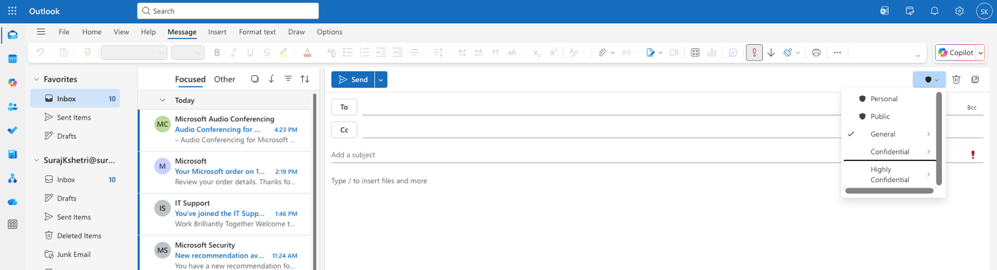

* Documents

**PHASE 7 — Real IT Support Scenarios**

**Scenario 1 — Onboarding**

For a new employee:

* Create user

* Assign licenses

* Add to groups

* Configure mailbox

* Add to Teams

* Enroll device

**Scenario 2 — Offboarding**

For a leaving employee:

* Block sign‑in

* Reset password

* Convert mailbox to shared
* 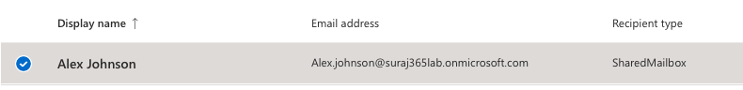

* Remove licenses

* Wipe device

Archive data

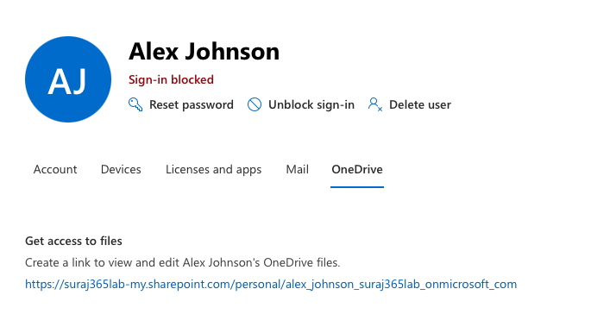

END